MATANUSKA-SUSITNA BOROUGH
MSB Fish and Wildlife Commission
AGENDA

Edna Devries, Mayor  Andy Couch – Chair  Peter Probasco – Vice Chair  Gabriel Kitter  Howard Delo  Larry Engel  Tim Hale  Bill Gamble  Kendra Zamzow  Jim Sykes – Ex officio member  Maija DiSalvo – Staff | 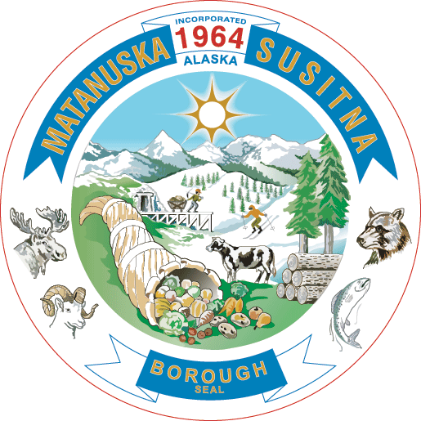 | Michael Brown, Borough Manager  PLANNING & LAND USE DEPARTMENT  Alex Strawn, Planning & Land Use Director  Vacant, Planning Services Manager  Jason Ortiz, Development Services Manager  Fred Wagner, Platting Officer  Assembly Chambers  Dorothy Swanda Jones Building  350 E. Dahlia Avenue, Palmer

December 5, 2024
SPECIAL MEETING: Alaska Department of Fish & Game (ADF&G)
Fishing Season Summary
5:00 p.m.

Ways to participate in MSB Fish and Wildlife Commission meetings:

IN-PERSON: Assembly Chambers, DSJ Building

REMOTE PARTICIPATION VIA MICROSOFT TEAMS:

Join on your computer:
Click here to join the meeting
Meeting ID: 212 411 183 809
Passcode: wq6yVK
Or call in (audio only):
1-907-290-7880
Phone Conference ID: 956 490 599#

- CALL TO ORDER

- ROLL CALL – DETERMINATION OF QUORUM

- LAND ACKNOWLEDGEMENT & RECOGNITION

"We acknowledge that we are meeting on traditional lands of the Dena’ina and Ahtna Dene people, and we are grateful for their continued stewardship of the land, fish, and wildlife throughout time immemorial."

- PLEDGE OF ALLEGIANCE

- APPROVAL OF AGENDA

- INTRODUCTIONS

  - FWC Opening Statement (5 min)
  - ADF&G Opening Statement (5 min)

- AUDIENCE PARTICIPATION (three minutes per person – 30 min, may vary)

- PRESENTATIONS

  - Staff Report (5 min)
  - ADF&G
    - Commercial Fishing Notable Highlights & Observations (10 min)
    - Sport Fishing Notable Highlights & Observations (10 min)
  - NOAA
    - Federal Inseason Management Report (10 min)

- ITEMS OF BUSINESS

- Dialogue on Upper Cook Inlet Fisheries & FWC Questions (30 min)

- ADF&G/NOAA/FWC FINAL COMMENTS (10 min)

- NEXT MEETING DATE: Thursday, December 12, 2024 @ 4:00 pm Assembly Chambers

- ADJOURNMENT

Disabled persons needing reasonable accommodation in order to participate at a MSB Fish and Wildlife Commission Meeting should contact the borough ADA Coordinator at 861-8432 at least one week in advance of the meeting.

