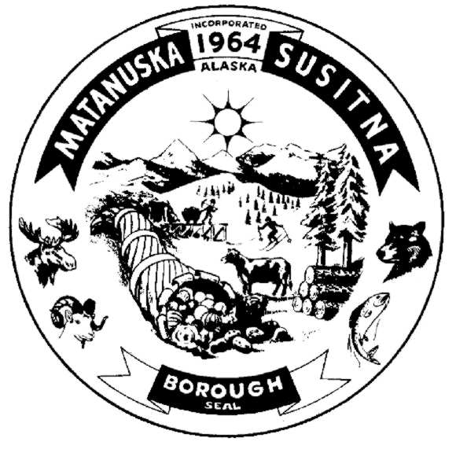
Matanuska-Susitna Borough
Department of Emergency Services
680 North Seward Meridian Parkway • Wasilla, Alaska 99654
Phone (907) 373-8800 • Fax (907) 376-0799

LEAVE OF ABSENCE FORM
(For: EMS, Fire & Rescue)

MEMBER: ____________________ SERVICE:
FSA:_______________________

EMS: _______________________

RESCUE:___________________

I hereby submit this request for a Leave of Absence from the above service or services commencing _____________________, 20_____ and ending __________________, 20_____.

State Reason for Leave of Absence:_______________________________________________

_____________________________________ _____________________
MEMBERS SIGNATURE DATE

_____________________________________ _____________________
SERVICE / DISTRICT CHIEF DATE

Please Forward Original to DES Administrative Office ________________________
Date Received

